JOIN de tablas:

SELECT * FROM mascotas;
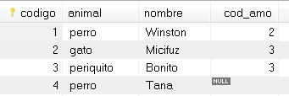

SELECT * FROM amos;
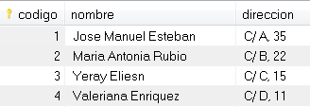

SELECT *
FROM mascotas INNER JOIN amos ON amos.codigo=mascotas.cod_amo;
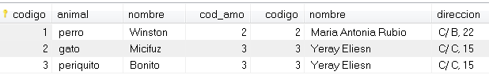

SELECT *
FROM mascotas LEFT JOIN amos ON amos.codigo=mascotas.cod_amo;
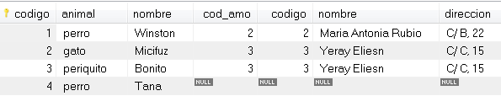

SELECT *
FROM mascotas RIGHT JOIN amos ON amos.codigo=mascotas.cod_amo;
